**FCS User's Manual**

**"AppSetup"**

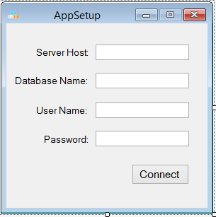

- When FCS is in its First Use , This Form

will show up for database connection and/

or when FCS detect wrong database

connection.

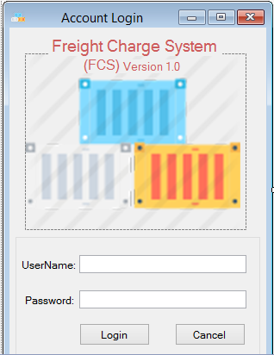

**"Login Form"**

-Every time the FCS will be open ,This Form

will show up user's account.

**Freight Transaction**

1. Extract a "Purchase Order" to a excel file . MUST BE (.xls)

2. Open the extracted Report , then Copy the list of the products.

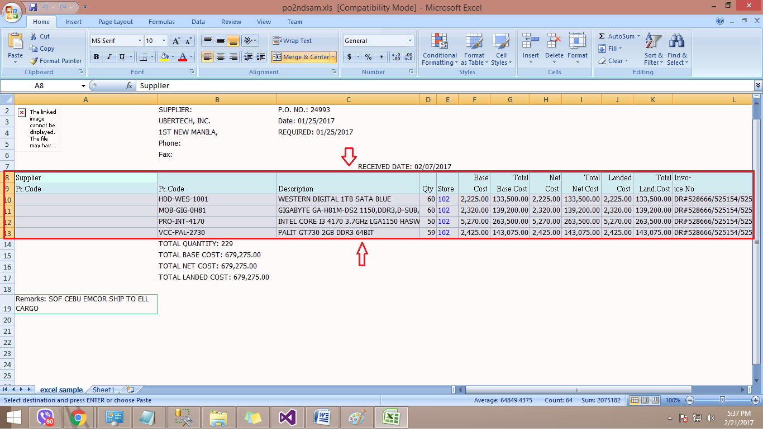

3. Click "Insert Worksheet"

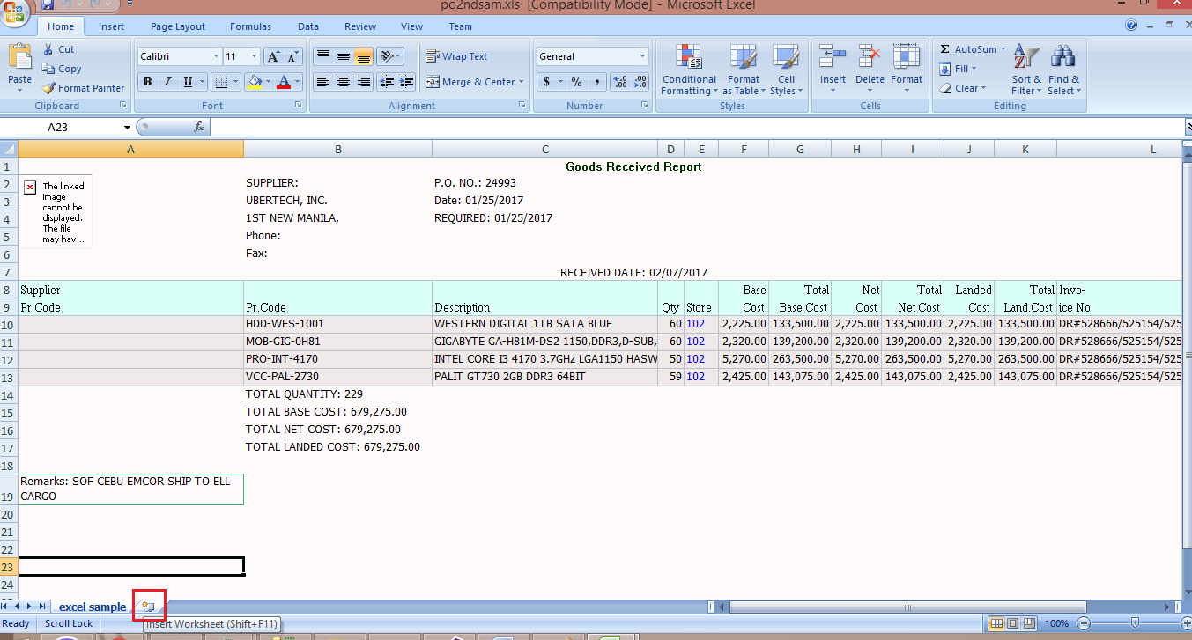

4. Paste the list of product to the "Sheet1" , Then Save the excel file. MUST BE (.xls)

Then Close the file.

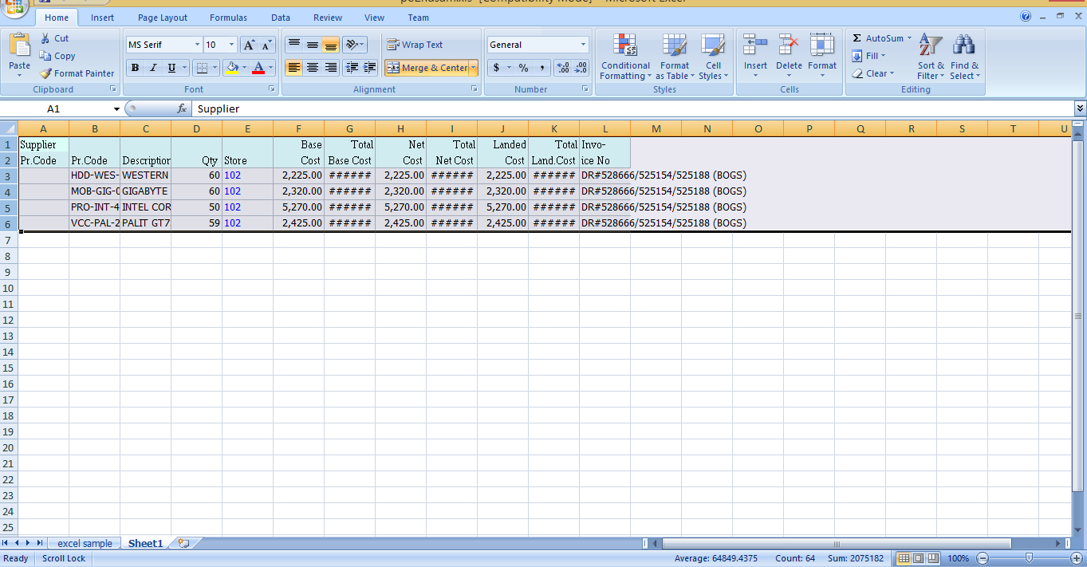

**"New"**

-FCS start of Freight Transaction.

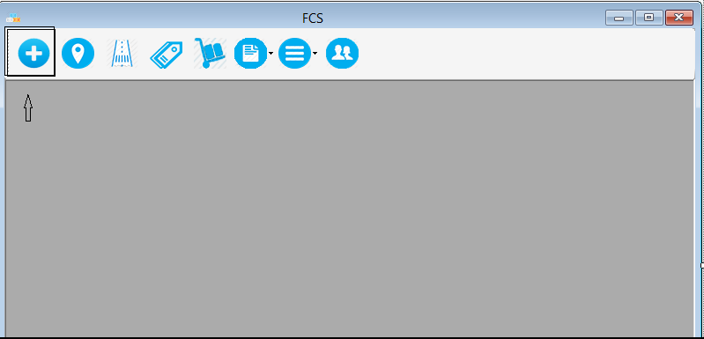

5.

6. Click "Upload" to upload Excel file.

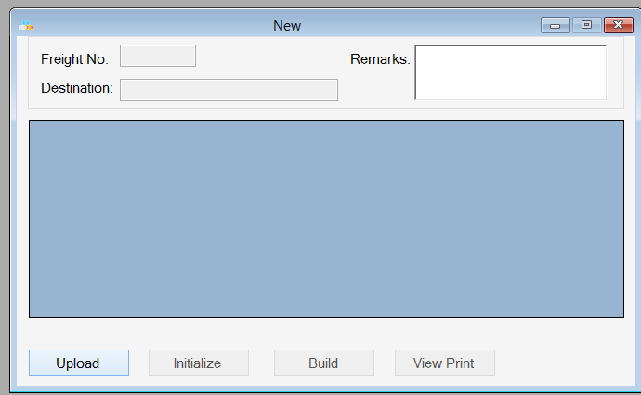

7. Click "Initialize " and let the System Read and Get details and information's need .

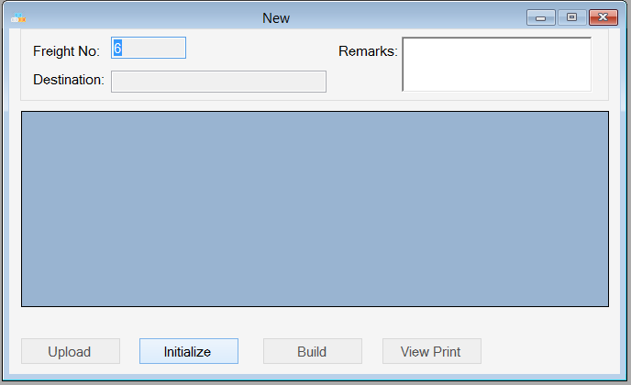

8.

Note:

FCS will exclude items that doesn't have "Box Code" or "LocationCode" or RouteCode or ItemQty. Item should have no missing information.

If Item don't have a BoxCode check the "Item" Form if the item is existing and have a tag of a BoxSetup or Check in the "Box Set" Form if a box set is created.

If Item don't have LocationCode check if the StoreCode in the excel file is existing in the Location List of the "Location" Form.

If Item don't have RouteCode check in the "Location" Form if the Location have a tag of a "SRoute"(ShipmentRoute) or check in the "Shipment Route" Form if a Route is created.

(1) User can exclude items .

(2) User can edit the quantity of the item.

(3) User can add remarks.

(4) User can cancel the transaction by closing the form "New" .

4

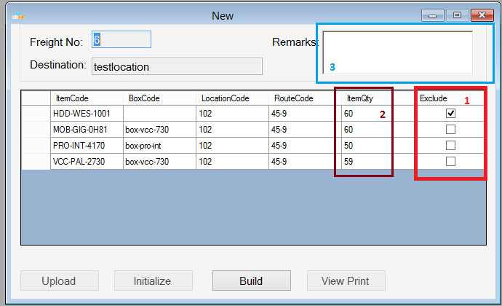

9. "Click Build" for finalizing the Freight Transaction.

10. Click "View Print" for printing the Waybill of the Freight Transaction.

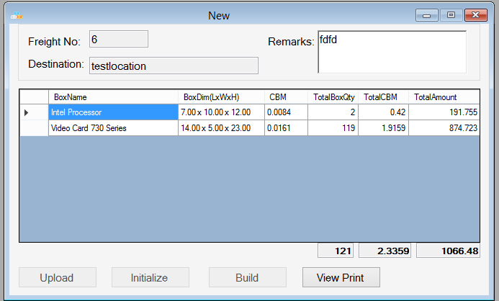

**"Location"**

-Add , edit , delete of a location

Note: Double Click the "SRoute TextField" for tagging to a Shipment Route.

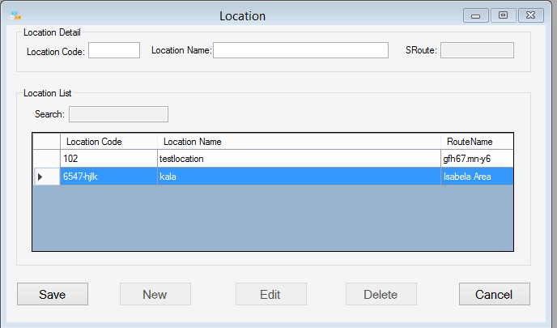

After double clicking the "SRoute TextField" . This is the list of the ShipmentRoute that are Created in "Shipment Route" Form.

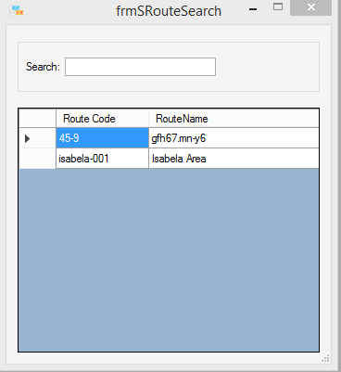

**"Shipment Route"**

-Add , edit of a Shipment Route.

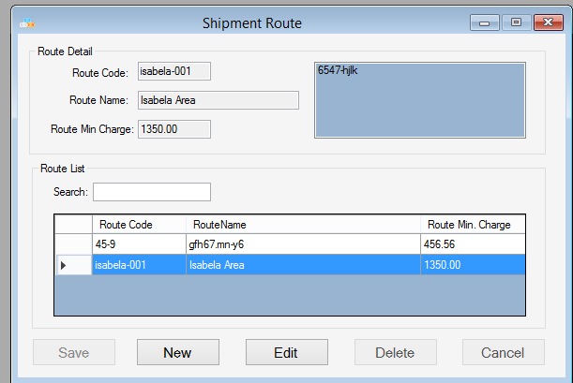

**"Item"**

-Add , edit , delete of a location

Note: Double Click the "BSetup TextField" for tagging to a Box Set.

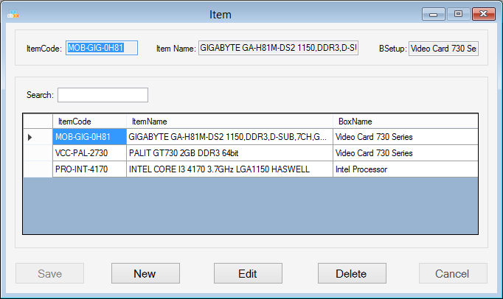

After double clicking the "BSetup TextField" . This is the list of the Box Set that are Created in "Box Set" Form.

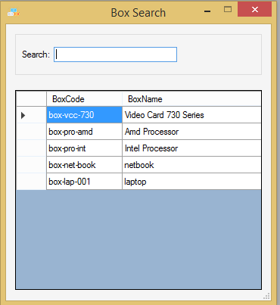

**"Box Set"**

-Add , edit of a Box Set.

